“System Resource Alert and Notification System”
A Project Report Submitted in the partial fulfillment of the requirements for the award of the degree of

BACHELOR OF TECHNOLOGY
In
DEPARTMENT OF COMPUTER SCIENCE ENGINNERING

By

Kolavali Sanjana 2520030614
Kompelli Saanvi 2520030083
R C Sai Sharan 2520030128

Under the Esteemed Guidance of

Dr. K. Anusha Assistant Professor

Department of Computer Science and Engineering




K L (Deemed to be) University DEPARTMENT OF COMPUTER SCIENCE ENGINEERING
&
DEPARTMENT OF COMPUTER SCIENCE AND INFORMATION TECHNOL

Declaration
We hereby declare that the project entitled “System Resource Alert and Notification System” is undertaken as part of our Operating Systems Hackathon project at KL (Deemed to be) University. This project focuses on understanding the practical implementation of Operating Systems concepts through a Linux-based resource monitoring system developed using the C programming language. The system monitors CPU utilization, memory usage, disk space, and running processes, and generates alerts when predefined resource usage thresholds are exceeded. It also supports configurable thresholds, alert logging, and continuous monitoring.
The implementation details and test results presented in the final report shall reflect the work actually completed by the team.

Kolavali Sanjana 2520030614
Kompelli Saanvi 2520030083
R C Sai Sharan 2520030128

K L (Deemed to be) University
DEPARTMENT OF COMPUTER SCIENCE ENGINEERING

CERTIFICATE

This is certify that the mini project based report entitled “SYSTEM RESOURCE ALERT AND NOTIFICATION SYSTEM” is a bonafide work done and submitted by Kolavali Sanjana– 2520030614 , Kompelli Saanvi- 2520030083, R C Sai Sharan- 2520030128 in partial fulfillment of the requirements for the award of the degree of BACHELOR OF TECHNOLOGY in Department of Computer Science Engineering, K L (Deemed to be University), during the academic year 2026-2027.

Signature of the Guide

Signature of the Course Coordinator Signature of the HOD

ACKNOWLEDGEMENT
We express our sincere gratitude to our project guide, Dr. K. Anusha, Assistant Professor, Department of Computer Science and Engineering, KL (Deemed to be) University, for her guidance and encouragement throughout this project.
We thank our department and university for providing the resources and learning environment required to understand Operating Systems concepts. We also thank our teammates, faculty members, and everyone who supported us in completing this project.

Abstract

The System Resource Alert and Notification System is a Linux-based application developed using the C programming language to monitor system resources and identify excessive resource utilization. The project focuses on monitoring CPU usage, memory usage, disk space, and running processes.
The system collects resource information from the Linux operating system, calculates utilization percentages, and compares the values with predefined thresholds. When CPU, memory, or disk usage exceeds the configured threshold, the system generates an alert. Alert information is stored in a log file with timestamps for later reference. The application also supports continuous monitoring with a configurable time interval.
The project uses Linux system interfaces, GCC, file handling, process information, and configuration files. It demonstrates important Operating Systems concepts through practical implementation and provides a foundation for future improvements such as automated notifications, graphical dashboards, and historical resource analysis.
Keywords: Linux, C programming, CPU monitoring, memory management, disk monitoring, process monitoring, resource alerts, GCC.

Index

S.  No. | Chapter | Topics / Subtopics | Page No.
 | Acknowledgement |  | i
 | Abstract |  | ii
1 | Introduction |  | 1–5
 |  | 1.1 Background of the Project
 |  | 1.2 Problem Statement
 |  | 1.3 Scope of the Project
 |  | 1.4 Objectives of the Project
 |  | 1.5 Importance of the Application
 |  | 1.6 Target Users / Audience
2 | OS Concepts and Background Study |  | 6–12
 |  | 2.1 Operating System Concepts Related to the Project
 |  | 2.2 Existing Methods / Algorithms
 |  | 2.3 Proposed Approach
 |  | 2.4 Advantages of the Proposed Approach
3 | System Requirements |  | 13–  17
 |  | 3.1 Hardware Requirements
 |  | 3.2 Software Requirements
 |  | 3.3 Operating System Environment – Ubuntu / WSL
 |  | 3.4 Development Tools and Compilers
4 | Technology and Tools Used |  | 18–  22
 |  | 4.1 C / C++ Programming
 |  | 4.2 GCC Compiler
 |  | 4.3 Linux System Calls
 |  | 4.4 POSIX Threads / Synchronization
 |  | 4.5 Linux Commands and Utilities
 |  | 4.6 Other Tools / Libraries Used
5 | System Architecture and Design |  | 23–  29
 |  | 5.1 Overall System Architecture
 |  | 5.2System Workflow
 |  | 5.3 Flowchart / Data Flow
 |  | 5.4 Module Description

 |  | 5.5 Input and Output Design
6 | Implementation |  | 30–  45
 |  | 6.1 Module-wise Implementation
 |  | 6.2 Algorithm / Pseudocode
 |  | 6.3 Core C / C++ Implementation
 |  | 6.4 Linux System Calls / APIs Used
 |  | 6.5 Process / Thread Implementation
 |  | 6.6 IPC / Synchronization Implementation
 |  | 6.7 Memory Management Implementation
 |  | 6.8 Optional User Interface Implementation
7 | Execution and Demonstration |  | 62–  67
 |  | 7.1 Compilation in Ubuntu
 |  | 7.2 Execution Commands
 |  | 7.3 Sample Inputs and Outputs
 |  | 7.4 Screenshots of Execution
 |  | 7.5 Demonstration of OS Concepts
8 | Conclusion |  | 79–  83
 |  | 8.1 Summary of the Project
 |  | 8.2 Objectives Achieved
 |  | 8.3 Results Achieved
 |  | 8.4 Skills and Learning Outcomes
9 | References |  | 84–  86
 |  | 9.1 Books
 |  | 9.2 Research Papers
 |  | 9.3 Linux / GNU Documentation
 |  | 9.4 Online Resources

Chapter 1: Introduction

Background of the Project
An operating system manages the hardware and software resources of a computer. These resources include the processor, memory, storage devices, and running processes. Monitoring these resources is important for maintaining system performance and identifying potential problems.
Linux provides system information through interfaces such as the /proc filesystem and system functions that retrieve filesystem statistics. These interfaces allow programs to obtain information about resource utilization and running processes.
The System Resource Alert and Notification System is developed using C in an Ubuntu/Linux environment. It collects resource statistics, displays usage information, checks configured thresholds, and generates alerts when required.

Problem Statement
Excessive resource utilization can affect the performance and stability of a computer system. High CPU usage can slow down processing, excessive memory consumption can reduce available memory, and insufficient disk space can prevent applications from storing data.
Manually checking every system resource is inconvenient and may delay the identification of resource-related problems.
Therefore, the project aims to develop a lightweight Linux application that monitors system resources, compares utilization with configurable thresholds, and alerts users when resource usage exceeds the permitted limits.

Objectives of the Project
The main objectives are:
- To develop a system monitoring application using C.
- To monitor CPU utilization.
- To calculate total, used, and available memory.
- To monitor total, used, and available disk space.
- To inspect running processes and their memory usage.
- To configure resource thresholds using a configuration file.
- To generate alerts when resource usage exceeds configured limits.
- To record alerts with timestamps in a log file.
- To support continuous resource monitoring.
- To gain practical experience with Linux system programming.

Scope of the Project
The project focuses on resource monitoring in a Linux environment.
Its scope includes CPU, memory, disk and process monitoring; configurable thresholds; terminal-based reports; threshold-based alerts; alert logging; and continuous monitoring.
The current implementation is designed as a lightweight command-line application rather than a graphical monitoring platform.

Importance of the Application
This project connects Operating Systems theory with practical programming. It demonstrates how a C application obtains system information, performs resource calculations, accesses files, and identifies resource utilization that exceeds specified limits.
It can serve as a learning tool for students studying Linux system programming, resource management, and operating system interfaces.

Chapter 2: OS Concepts and Background

Study

Operating System Resource Management
An operating system manages the resources required by applications. These resources include processor time, main memory, storage space, and process execution.
Monitoring these resources helps users understand how the system is being utilized and whether resource usage is approaching configured limits.

CPU Monitoring
The Central Processing Unit (CPU) executes instructions and performs computations.
CPU utilization indicates the proportion of processor time spent working rather than remaining idle. The project monitors CPU usage and compares the calculated percentage against the configured CPU threshold.

Memory Monitoring
Memory is used to store program instructions and data during execution.
The memory monitoring module obtains memory statistics and reports total, available, and used memory, along with the percentage of memory utilization.
This information helps identify situations where available memory is becoming limited.

Disk Monitoring
Disk storage is used to store operating system files, applications, and user data.
The disk monitoring module collects filesystem capacity information and calculates total, used, and available disk space. The resulting usage percentage is compared against the configured disk threshold.

Process Management
A process is a program that is currently executing. A Linux system may contain multiple processes belonging to system services, user applications, and background tasks.
The process monitoring module retrieves process information, including process IDs, process names, and memory usage. This allows users to inspect the processes currently running on the system.

Threshold-Based Alerting
A threshold is a predefined limit used to identify excessive resource utilization.
In this project, the default thresholds are:
Resource | Default threshold
CPU | 80%
Memory | 80%
Disk | 80%
When a monitored resource exceeds its configured threshold, the application displays an alert. Otherwise, it reports that the resource usage is within limits.

Linux System Interfaces
The application uses Linux system interfaces to obtain resource information.
- /proc/stat — provides CPU statistics.
- /proc/meminfo — provides memory statistics.
- /proc — contains information about running processes.
- statvfs() — retrieves filesystem capacity information.
These interfaces help applications obtain operating system information without requiring a separate database.

Chapter 3: System Requirements

Hardware Requirements
• Desktop computer or laptop.
• Minimum 2 GB RAM recommended.
• Keyboard and display.
• Sufficient disk space for source code and executables.

Software Requirements

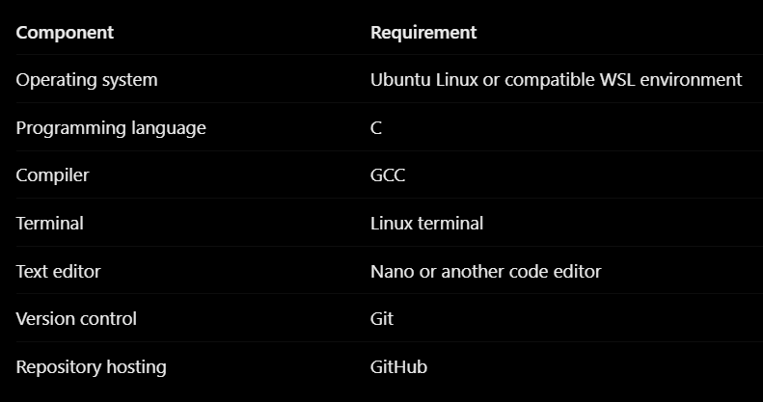

Operating System Environment
GCC: Compiles C source files into executable programs.
Nano: Used to create and edit source code and configuration files.
Git: Tracks source code changes and commits.
GitHub: Stores the project repository and provides access to the source code and documentation.

Chapter 4: Technology and Tools Used

C Programming Language
C is used to implement the shell because it provides access to low-level operating system interfaces and process-management functions.

GCC Compiler
GCC converts the C source code into an executable program. Example:
gcc -Wall -Wextra -o minishell minishell.c
The filename should be changed to match the actual source file.

Linux System Calls and Functions

Function Purpose

fork() Creates a child process

execvp() Executes an external program waitpid() Waits for or checks child processes chdir() Changes the current working directory getcwd() Retrieves the current working directory open() Opens a file
dup2() Redirects a file descriptor pipe() Creates a communication channel kill() Sends a signal to a process sigaction() Configures signal handling
These functions are relevant to the design; the final report should list only those actually used in the submitted code.

Chapter 5: System Architecture and Design

Overall System Architecture
The system contains the following logical components:

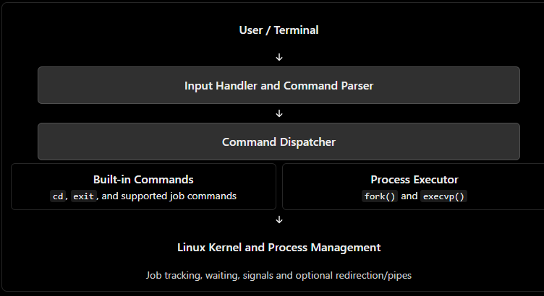

Chapter 6: Implementation

Main Shell Loop
The shell repeatedly accepts input and processes commands. The loop continues until the user enters the supported exit command or another defined termination condition occurs.

Foreground Execution
When the user enters an external command without &, the shell creates a child process and waits for its completion using waitpid().

Background Execution
When a command ends with &, the shell should execute it in the background and return to the prompt without waiting for normal completion.
6.4 Pseudocode START SHELL

WHILE shell is running:
Display prompt
Read user command
Parse command and arguments

IF command is empty:
Continue

IF command is a built-in: Execute built-in command
ELSE:
Create child process using fork()

IF process creation fails:
Display error

ELSE IF current process is child: Execute program using execvp() Display error if execution fails

ELSE IF command is foreground: Wait using waitpid()

ELSE:
Add process to job table Return to prompt

Check completed background jobs

END WHILE

STOP SHELL

6.5 Error Handling

The shell should handle invalid commands, empty input, process-creation failures, and program-execution failures. It should display understandable error messages and continue operating when appropriate.

Chapter 7: Execution and Demonstration

7.2 Suggested Test Cases

Test command Expected result

pwd Displays the current directory

ls Lists files and directories

echo Hello Displays the given text

cd .. Changes the shell's directory

sleep 10 & Returns to the prompt while the job runs jobs Displays tracked jobs, if implemented ls > out.txt Redirects output to a file, if implemented
ls \| wc Connects command output through a pipe, if implemented Invalid command Displays an error without crashing
Record Pass or Fail only after actually running each test in your shell.

7.3 Screenshots
Insert screenshots of your own execution showing:
- The shell prompt and basic commands.
- Foreground command execution.
- Background command execution.
- Job listing, if implemented.
• Redirection and pipe output, if implemented.

- Error handling for an invalid command.

Chapter 8: Team Contributions
The following responsibilities are suggested based on your team of three. Update them to reflect each member's actual contribution.

Team member Suggested contribution

Cherukumudi Sri Dhruthi
Input handling, command parsing and built-in commands

Kachana Mahima Process execution, foreground/background execution and report preparation Ravi Abhishiktha Background job management, signal handling and testing
All team members can contribute to integration, debugging, testing, and final presentation preparation.

Chapter 9: Results, Limitations and Future Enhancements

Expected Results
The project aims to demonstrate how a basic Linux shell accepts and executes commands, creates processes, handles foreground and background tasks, and monitors process completion.
The actual results must be recorded after testing the submitted implementation. Number of test cases passed: To be filled after testing.
Features successfully demonstrated: To be filled after testing.

Limitations
    - The mini shell may support fewer commands and features than Bash.
    - Advanced command parsing and shell scripting may not be supported.
    - Complete foreground/background terminal job control requires additional process-group and terminal management.
    - Redirection, pipes, and commands such as fg and bg work only if implemented correctly.

  - ​Future Enhancements

    - Add command history.
    - Implement tab completion.
    - Improve command parsing and error handling.
    - Improve foreground and background job control.
    - Add more advanced pipe and redirection support.
    - Add automated testing and build automation using a Makefile.

Chapter 10: Conclusion
The Mini Linux Shell with Background Job Management project provides practical experience with important Operating Systems concepts. By designing a shell in C, the team studies command parsing, process creation, program execution, process synchronization, signal handling, and background job management.
The project connects theoretical knowledge with practical Linux programming and improves understanding of how applications interact with the operating system. Future enhancements can make the shell more reliable and provide additional command-line features.

References
- Michael Kerrisk, The Linux Programming Interface, No Starch Press.
- GNU Compiler Collection (GCC) documentation: GCC Documentation.
- Linux manual pages: Linux man-pages.
- The Open Group, POSIX specifications: POSIX Documentation.
.

